TRAVEL TIPS FOR JORDAN

At the heart of the Middle East, Jordan sits at one of the most important crossroads in the entire world. As such it has long been the subject of fascination for just about every empire that has turned its covetous gaze on this rich and beautiful territory. The Israelites, the Romans, the Byzantines, the Ottomans and the British have all been here in the past.

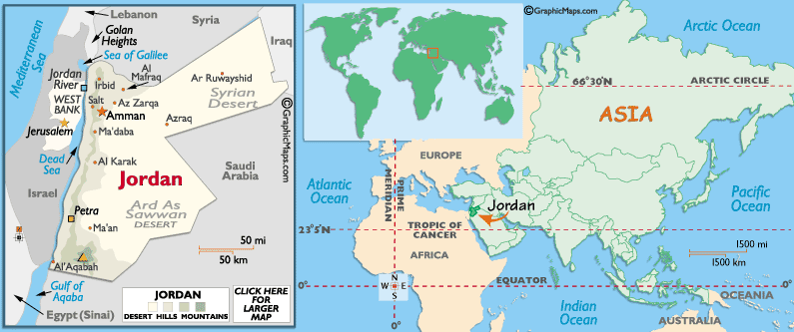

Visa The visa is to be obtained prior to arrival in the country

Getting there:
By Air: The national airline is Royal Jordanian Airlines (RJ) There are flights to 50 destinations in the Middle East, Europe, North America, the Far East and Asia.
International airports: Queen Alia International (AMM) is 35km (22 miles) southeast of the capital - Amman, to which it is connected by a good highway (travel time – approximately 40 minutes). There is a regular bus service to Amman every 30 minutes (travel time – approximately 50 minutes), and taxis are also available. Facilities include duty free shops, bank/bureau de change, eating and shopping facilities, and car hire (Avis and Hertz).
Departure tax: Approx JD 6.00 for individual tourists. Transit passengers are exempt.
By Sea: The only port is Aqaba, which is on the cruise itineraries for Cunard, P&O and Swan Hellenic. Car and passenger ferries from Aqaba to Cairo and Aqaba to Nuweiba operate twice-daily and there is also a high-speed hydrofoil service. There is a weekly passenger service to Suez and Jeddah.

Departure tax: Approx JD 6.00 for individual tourists.

By Rail: The Hijaz Railway operates on the old Ottoman track between Amman and Damascus (Syrian Arab Republic).

Getting around:
Air: Royal Wings operates regular flights from Amman to Aqaba. It is also possible to hire executive jets and helicopters.
Road: Main roads are good (there are nearly 3000km (1900 miles) of paved roads in the country), but desert tracks should be avoided. It is important to make sure that the vehicle is in good repair if travelling on minor roads or tracks. Take plenty of water and follow local advice carefully. In case of breakdown, contact the Automobile Association. Traffic drives on the right. There are frequent passport controls along the Red Sea and travellers are advised to have their papers ready.
Bus: Services are efficient & cheap. Alpha, JETT & Petra all operate modern, airconditioned fleets.
Taxi: Share-taxi service to all towns on fixed routes is also available for private hire. Share-taxis to Petra should be booked in advance owing to demand.
Car hire: Avis & four national companies operate services in the main towns, including Amman and Aqaba, available also from hotels and travel agents. Drivers are available for the day. Documentation: National driving licences are accepted if they have been issued at least one year before travel. However, an International Driving Permit is recommended. Visitors are not allowed to drive a vehicle with normal Jordanian plates unless they have a Jordanian driving licence.

Note: When using routes which go near the Israeli border, the traveller should always have all papers in order & within reach.

Urban: There are conventional buses and extensive fixed-route ‘Servis’ (share-taxis, most seating up to seven) in Amman. The ‘Servis’ are licensed, with a standard fare scale, but there are no fixed pick-up or set-down points. Vehicles often fill up at central or outer terminal points and then run non-stop.

Weather:
The best times to visit Jordan are October-December and April-June when it's warm during the day and cool in the evening.
Summers are very warm, with temperatures permanently over 30°C in most parts of the country and hitting mid -40°C in some areas. Rain falls most frequently November-March. Winters can be very drizzly, damp and cool - and snow occasionally falls in Amman and the mountains. Aqaba is usually a few degrees warmer than the rest of the country thanks to the influence of the sea.
The Badia region shows some variation in temperature according to which desert area you are in, but generally, it has an inhospitable desert climate. Rainfall is minimal throughout the year and in summer daytime temperatures peak at well over 40°C, while dropping to near freezing at night. This variation in diurnal temperatures mean that any visitors to Jordan should ensure that they have a variety of clothing with them, even if visiting in summer a sweater may be necessary after nightfall.

Time:

Jordan is 3 hours 30 minutes behind India and 2 hours 30 minutes behind India between October to March

Currency:
The Jordanian Dinar (JOD). JOD1 = 100 piasters = 1000 filis
Notes: JOD50, JOD20, JOD10, JOD5
Coins: JOD1; 50, 25, 10, 5, piasters; and 25, 10, 5 filis
Credit cards: American Express and Visa cards are widely accepted, while MasterCard is more limited in use. Check with your credit and debit card company for details of merchant acceptability and other services that may be available.
It is a good idea to always have a supply of small change. Many traders and taxi drivers seem to have a habit of not carrying change.
Foreign currencies can be exchanged easily in banks and bureaux de changes located at tourist sites and city centres. Most hotels also provide exchange facilities although rates are often not as favourable as elsewhere. Traveller's cheques are accepted by licensed banks and bureaux de change. To avoid additional exchange rate charges, travellers are advised to take traveller's cheques in US Dollars.
Banks tend to open from 08h30-12h30 and 15h30-17h30 Sat to Thu. You should note that during Ramadan banking hours are severely curtailed. Most banks will only open during the morning throughout the holy month.

Language:
Arabic is the official language. English is widely spoken in the cities. French, German, Italian and Spanish are also spoken.

Electricity:

220 volts AC, 50Hz. Round two-pin plugs are used. Lamp sockets are screw-type, and there is a wide range of wall sockets

Events:
Jordanian holidays and festivals are mostly Islamic. The big one is Ramadan, a month where everyone fasts between sunup and sunset to conform to the fourth pillar of Islam. Ramadan ends with a huge feast, Eid al-Fitr, where everyone prays together, visits friends, gives presents and stuffs themselves. Eid al-Adah, held around February, is the other big feast of the year, and marks the time when Muslims should make the pilgrimage to Mecca. Non-religious holidays include Independence Day, on 25 May.

International dialling code: 962
Area codes: Amman: 6, Petra: 3, Aqaba: 3, Jerash: 2

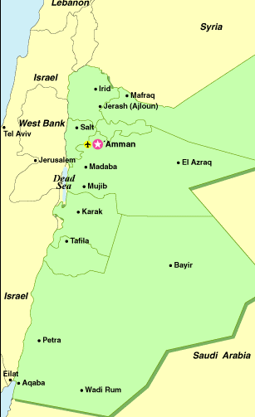

CITIES:

AMMAN
Amman, the capital of Jordan, is a fascinating city of contrasts – a unique blend of old and new, ideally situated on a hilly area between the desert and the fertile Jordan Valley.
In the commercial heart of the city, ultra-modern buildings, hotels, smart restaurants, art galleries and boutiques rub shoulders comfortably with traditional coffee shops and tiny artisans' workshops.
Due to the city’s modern-day prosperity and temperate climate, almost half of Jordan’s population is concentrated in the Amman area. The residential suburbs consist of mainly tree-lined street and avenues flanked by elegant, almost uniformly white houses, in accordance with a municipal law, which states that all buildings must be faced with local stone.
The downtown area is much older and more traditional with smaller businesses producing and selling everything from fabulous jewellery to everyday household items
The capital of Jordan and its largest city, Amman is just 70km north-east of Jerusalem. Amman is a fantastic blend of ancient and modern.
The city centre is a bustling modern metropolis of high rise buildings, offices and upscale shopping malls. However, amidst this modernity you'll find relics of the ancient world including the 2,000-year-old Roman Amphitheatre, still used for the tourist oriented shows that trace the history of the region and its customs. The location is one of the oldest continuously inhabited human settlements on earth.

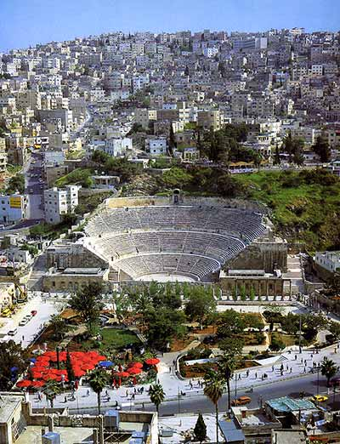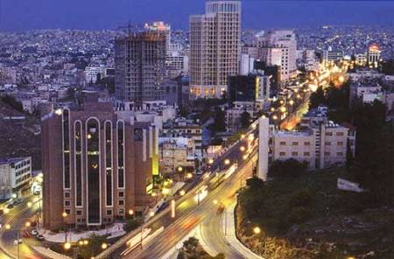

The earliest settlements discovered in excavations here have been dated at over 9,000 years old. Amman's many museums trace the city's history through objects and artefacts recovered from the earth. The Jordan Archeological Museum near the amphitheatre contains a collection that ranges from the Stone and Iron Ages through the rule of the Romans and the Byzantines among others. In the heart of Amman, you will find the Citadel high on Jabal Al Qala'a, one of the seven hills that define the city. It contains relics from all the various epochs that reigned in the region. Head back down to the city proper to admire the Hussein Mosque and browse the souks.

To and from the airport
Queen Alia International Airport is 32 kilometres south east of Amman city centre and is Jordan's gateway to the world. Airlines that service Amman include Royal Jordanian, Air France, British Airways, Lufthansa and KLM.
By bus
A bus service, Airport Express, leaves the airport every half hour to the city's downtown Abdali bus station from 06h00-22h00 and every two hours from 23h00-05h00. The trip takes about 45 minutes.
By Taxi
The easiest and fastest way to the city is still by taxi, which takes about a half-hour.
Trains
The Hijaz Railway train runs twice a week between Amman and Damascus on the same track that was built by the Ottomans at the beginning of this century. The train departs Amman at 08h00 every Monday and Thursday, arriving at Damascus at 17h00 hours, and leaves Damascus every Sunday at 07h30 to arrive in Amman at 17h00.
Buses
The main bus stations in Amman are the Abdali bus station for buses headed north and west, Wahadat for coaches south, and Raghadan for Amman and nearby regions. Local buses can be confusing. There are private bus companies that service major tourist areas. JETT (Jordan Express Travel & Tourism, runs air-conditioned coaches from Amman to Aqaba, Petra, and other destinations. Coaches leave from the Abdali and Wahdat bus stations and tickets should be booked at least a day in advance. The Alpha Tourist Bus Company also operates regular bus services.
Taxis
Taxis are metered and inexpensive, and are the fastest way to get around the city. White service taxis travel fixed routes and are shared. Yellow taxis are private and can be hailed on the street or from outside some of the larger hotels. Taxis have meters but are not always used at night, so a fare must be agreed on beforehand.
Driving
The road network in Jordan is excellent, which makes renting a car a good option. In Jordan, traffic drives on the right hand side and road signs are written in Arabic and English.

SIGHTSEEING IN AMMAN:
The Citadel (Jebel Al Qal'a):
Soaring high over Amman, the Citadel marks the site of one of the area's earliest fortifications, and is the most prominent attraction in the city. Excavations have uncovered artefacts from as early as the Neolithic period. The walls surrounding the complex have been rebuilt a number of times, but it's what's inside the complex that is most intriguing, namely the Umayyad Palace, Temple of Hercules and a Byzantine basilica.
The opulent Umayyad Palace (Al Qasr) is believed to have served as the regional administrative centre from 720AD until 750AD. Within the palace area are assembly rooms and an impressive colonnaded road. An extension of the site includes a beautiful palace bath and mosque. The gateway leading to the reception hall makes for a grand entrance. Close to the palace lie the remains of the small Byzantine basilica featuring some lovely mosaics. Not far from the church sits the Temple of Hercules dating from the reign of emperor Marcus Aurelius (161-180AD), though only the podium and columns remain standing, so a fairly active imagination is required to picture how it would have been in its heyday.

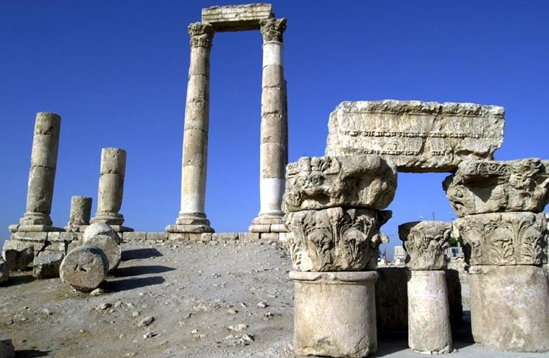
The Roman Amphitheatre/Odeon:
The Roman Amphitheatre stands as Amman's most impressive relic. Built during the rule of Antoninus Pius (138-161AD) the amphitheatre spans 33 rows that can seat 6,000, making it a superb venue for the cultural performances held here during the summer. In front of the amphitheatre are the remains of the Forum, which at one time was one of the largest public squares in the entire Roman Empire, though very little remains of it now - it is used basically as a walkway. Next to the amphitheatre sits the recently restored Odeon, a 600-seat theatre built in the 2nd century, about the same time as the amphitheatre.
There are two small museums located at the Roman theatre, each worth a visit. The Jordan

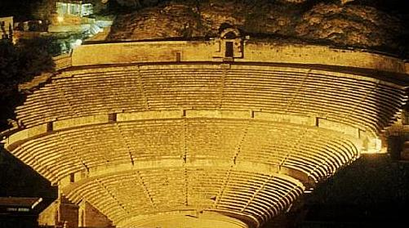

Folklore Museum attempts to re-create traditional Jordanian life, featuring 19th-century handicrafts, as well as historical costumes and musical instruments.
Open: daily 08h00-16h00 (winter), 08h00-19h00 (summer).
The Museum of Popular Traditions (also known as the Traditional Jewels and Costumes Museum) displays Jordanian costumes and jewellery dating back 100 years or more. The museum also exhibits mosaics from Madaba and Jerash dating from the 6th century.
Open: daily 08h00-16h00 (winter), 08h00-17h00 (summer).
Jordanian Archaeological Museum:
This small museum, located at the Citadel, displays a collection dating from prehistoric times to the 15th century. Included are samples of the Dead Sea Scrolls found in the early 50s and Neolithic plaster statues of Ain Ghazal, considered the oldest representations of human figures. Also inside are anthropomorphic pottery coffins, which reveal all sorts of clues about ancient burial practices, along with human skulls from Jericho.
Open: daily 08h00-17h00 (winter), 08h00-19h00 (summer).
Nymphaeum:
Though it's not all that easy to find, restoration is underway at the Nymphaeum, the main fountain complex when Amman was known as Philadelphia. Completed in 191AD, the Nymphaeum comprised two storeys, part of which is believed to have contained a 600-square-metre pool, three metres deep, which was continuously refilled with fresh water. Jordan's Department of Antiquities is currently excavating the Nymphaeum, and ultimately hopes to restore the site to its original structure by 2010.
Darat Al Funun;
Darat Al Funun, established in 1993, serves as a haven for Jordan's arts scene, as well as for artists from the rest of the Arab world. Its three buildings, which overlook Amman, were constructed in the 1920s and used as residences, while an adjacent 6th-century Byzantine church has also been restored for use by the centre. The church, surrounded by the gardens, now provides a dramatic outdoor setting for the performing arts that form a part of Darat al Funun's multi-faceted programme. The art centre contains exhibition spaces, a research and video library, open workshops and studios, visiting artists' residence, and venues for the performing arts.
Open: daily 10h00-19h00.
King Abdullah Mosque:
Known for its massive mosaic blue dome, the King Abdullah Mosque adds a splash of colour to the mostly white architecture in Amman. Built between 1982 and 1989, the mosque was a memorial by the late King Hussein to his grandfather, King Abdullah, who was assassinated in 1952 at a mosque in Jerusalem. The mosque can hold up to 7,000 inside and another 3,000 outside in the courtyard. Visitors are welcome, and there is a small Islamic museum inside.
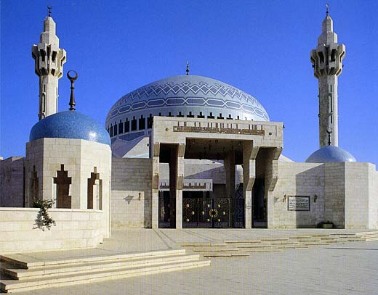

Kan Zaman Village:
Outside Amman, Kan Zaman Village is, as the name implies, a walled re-creation of a traditional Jordanian village. Inside the complex, visitors can watch artisans at work, such as glassblowers; shop at high-quality craft stores; see bread makers on the job and dine at the on-site restaurant, which serves traditional Middle Eastern fare. The waiters are also part of the musical entertainment, performing a bit of Jordanian song and dance. Kan Zaman is located in Yadudda, 11 km south of Amman off the Desert Highway.

Accommodation:
Amman is home to a number of international four-and five-star hotels, mostly clustered in the Jebel Amman and Shmeisani neighbourhoods, though there is a sprinkling throughout the downtown area as well. Rooms are often lavish and the luxuries abundant. Mid-range priced hotels tend to be located around the Abdali bus station and between the First and Fifth Circles.
The Regency Palace is a good central option. Located within easy walking distance of the city's main attractions, the hotel offers good value for money with comfortable rooms in modern surroundings.
A little further afield, the Bristol is a well-equipped hotel with a good standard of amenities - including a pool - and comfortable, well maintained rooms.One of the most luxurious places to stay is Le Meridien, also a few kilometres out of the centre, but with superb, modern amenities.

SIGHTSEEING IN JORDAN:
Petra:
The giant red mountains and vast mausoleums of a departed race have nothing in common with modern civilization, and ask nothing of it except to be appreciated at their true value - as one of the greatest wonders ever wrought by Nature and Man. It is one of the SEVEN WONDERS OF The WORLD.
Although much has been written about Petra, nothing really prepares you for this amazing place. It has to be seen to be believed.

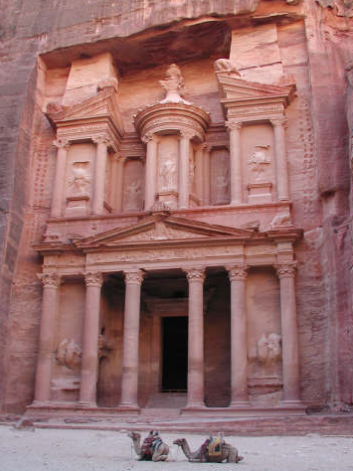

It is without doubt Jordan’s most valuable treasure and greatest tourist attraction. It is a vast, unique city, carved into the sheer rock face by the Nabataeans, an industrious Arab people who settled here more than 2000 years ago, turning it into an important junction for the silk, spice and other trade routes that linked China, India and southern Arabia with Egypt, Syria, Greece and Rome.
Entrance to the city is through the Siq, a narrow gorge, over 1 kilometre in length, which is flanked on either side by soaring, 80 metres high cliffs. Just walking through the Siq is an experience in itself. The colours and formations of the rocks are dazzling. As you reach the end of the Siq you will catch your first glimpse of Al-Khazneh (Treasury).
This is an awe-inspiring experience. A massive façade, 30m wide and 43m high, carved out of the sheer, dusky pink, rock-face and dwarfing everything around it. It was carved in the early 1st century as the tomb of an important Nabataean king and represents the engineering genius of these ancient people.
One of the world's most remarkable ancient settlements, the city of Petra sits in the steep sided canyon of the Wadi Musa. Known as the rose-red city, Petra has been hewn out of solid sandstone, its buildings carefully excavated caves, painstakingly carved by its founders over 2,000 years ago.
Amazingly, Petra was a secret, only known to the local nomads and traders until 1812, when an intrepid Swiss explorer, disguised as a pilgrim, was introduced to the city unwittingly. Even today Petra is loath to surrender its secrets; the site is only accessible via horse or camel ride through a 5m-wide narrow defile known as the Siq. The winding passageway of the Siq was much decorated, and you can still see the alcoves that once held statuary and tombs.
Once you reach the site, you're greeted with one of the most magnificent buildings in the complex, the treasury. Carved from the rock face its façade is one of the most ornate in the city. Continuing to the main site the most evident architecture is that of the Romans who ruled here from the 1st century AD and modernised the city to their model. However, there are still plenty of older relics.
One of the best experiences in Petra is to head up one of the surrounding hills and access the views across the city and the sandstone hills. The trip to the monastery and the "Place of Sacrifice" are two popular hikes taking around an hour from the city
Roman-style theatre, which could seat 3,000 people. There are obelisks, temples, sacrificial altars and colonnaded streets, and high above, overlooking the valley, is the impressive Ad-Deir Monastery – a flight of 800 rock cut steps takes you there.
Within the site there are also two excellent museums; the Petra Archaeological Museum and the Petra Nabataean Museum both of which represent finds from excavations in the Petra region and an insight into Petra's colourful past.
A 13th century shrine, built by the Mameluk Sultan Al Nasir Mohammad to commemorate the death of Aaron, the brother of Moses, can be seen on top of Mount Aaron in the Sharah range.
Inside the site, several artisans from the town of Wadi Musa and a nearby Bedouin settlement have set up small stalls selling local handicrafts, such as pottery and Bedouin jewellery and bottles of striated multi-coloured sands from the area.
It is not permitted for motorized vehicles to enter the site. But if you don’t want to walk, you can hire a horse or a horse-drawn carriage to take you through the one kilometre Siq. For the elderly and/or handicapped, the Visitors' Centre, close to the entrance of the Siq, will issue a special permit (at an extra fee), for the carriage to go inside Petra to visit the main attractions. Once inside the site, you can hire a donkey, or for the more adventurous, a camel - both come with handlers and take designated routes throughout the site.

Azraq:
Azraq is a unique wetland oasis located in the heart of the semi-arid Jordanian eastern desert, one of several beautiful nature reserves managed by the RSCN. Its attractions include several natural and ancient built pools, a seasonally flooded marshland, and a large mudflat known as Qa'a Al-Azraq. A wide variety of birds stop at the reserve each year to rest during their arduous migration routes between Asia and Africa. Some stay for the winter or breed within the protected areas of the wetland.
The best time to visit Azraq is late Autumn, Winter or Spring. Winter rains often create pools and marshes over the reserve, which continue to attract many seasonal species of birds. The success of bird-watching visits depends largely on the amount of water that has accumulated in the reserve.
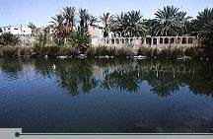

This spectacular oasis is located 110km (72miles) from Amman in the middle of the Jordanian desert. The name "Azraq" means blue in Arabic and originated from the colour of the water, which dazzles in the super-heated arid region. It is now the only eastern desert that still has water. The oasis and the wetlands that surround it have been restored to their former glory thanks to a costly programme of environmental restoration.
The oasis today is one of those fairytale sites of beauty and attracts up to half a million birds at any one time, who come for the life-giving moisture it contains. The water also attracts larger inhabitants, and you can see water buffaloes, hyenas and ibexes here as well as smaller desert denizens including snakes and lizards. The visitors' centre gives you the lowdown on the sheer diversity of wildlife that depends on the oasis to survive in the desert landscape.
You should also take the opportunity to explore the nearby region, which includes the fabulous desert castles of the Umayyads, built well over a thousand years ago. Qasr Azraq at the oasis was the base of Lawrence of Arabia, during his time fighting in the Arab revolt.

Shawmari Reserve:
The Shawmari Reserve is a breeding centre for some of the most endangered and rare wildlife in the Middle East. In this small reserve there is a large herd of magnificent Arabian Oryx, a species that was once on the verge of extinction. There are also ostriches, onagers and graceful desert gazelles. These animals are all rebuilding their populations in this safe haven, where they are protected from the hunting and habitat destruction that once threatened their existence.
The Shawmari Reserve supports a rich variety of desert plants, mainly because the vegetation inside the reserve is protected from the heavy grazing of sheep and goats outside its perimeters. Shawmari contains a very large number of species of plants, including Atriplex, a natural food source for the Onager and Oryx.

The Dead Sea:
Without doubt, the world’s most amazing place, the Jordan Rift Valley is a dramatic, beautiful landscape, which at the Dead Sea, is over 400 metres (1,312 ft.) below sea level. The lowest point on the face of the earth, this vast, stretch of water receives a number of incoming rivers, including the River Jordan. Once the waters reach the Dead Sea they are land-locked and have nowhere to go, so they evaporate, leaving behind a dense, rich, cocktail of salts and minerals that supply industry, agriculture and medicine with some of its finest products.
The Dead Sea is flanked by mountains to the east and the rolling hills of Jerusalem to the west, giving it an almost other-worldly beauty. Although sparsely populated and serenely quiet now, the area is believed to have been home to five Biblical cities: Sodom, Gomorrah, Adman, Zebouin and Zoar.

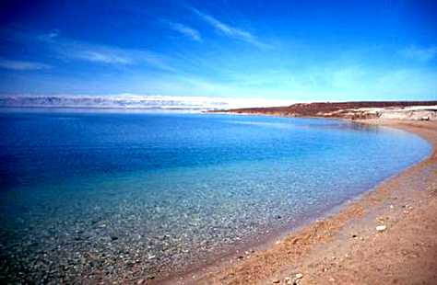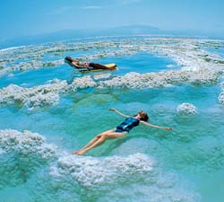

The leading attraction at the Dead Sea is the warm, soothing, super salty water itself – some ten times saltier than sea water, and rich in chloride salts of magnesium, sodium, potassium, bromine and several others.
In one word it's a "must". The Dead Sea is a natural phenomenon for many reasons; one being that it has 43 billion metric tons of salt making it the most saline body of water in the world. On the other side of the lake in Israel, one of the most significant archaeological finds ever was made: the discovery of the Dead Sea Scrolls.
The area is certainly atmospheric, but most visitors come here nowadays to sample the restorative powers of the waters. In the resorts that surround the lake, people are plastered in mineral rich mud from the shores of the sea, before plunging into the salty water where it's possible to float unsupported.
On the eastern shore of the Dead Sea is the Mujib Reserve, the lowest nature reserve on earth. Here you can view one of the largest types of mountain goat, the Nubian ibex, which has a protective breeding ground as it is close to becoming extinct. You can enjoy a hike through the reserve, a swim in the river or even take a tour down the River Mujib.

Tip:
If you are planning to combine a visit to the Dead Sea with a diving trip to Aqaba during your stay in Jordan, do the Dead Sea experience first. If you do it the other way around, the small cuts or grazes you may pick up from the coral reefs will soon let you know why this is the better option!

Karak:
On the road between Amman and Aqaba lie the remains of Kerak Castle, a Crusader stronghold dating back to 1142. The castle sits squarely on a rugged hilltop seeming to almost blend into the rough surrounding terrain of hills and rocky outcrops. Built on seven levels, the top one commanding superb views across the valley, its walls are still formidable.
An ancient Crusader stronghold, Karak sits 900m above sea level and lies inside the walls of the old city. The city today is home to around 170,000 people and continues to boast a number of restored 19th century Ottoman buildings, restaurants, places to stay, and the like. But it is undoubtedly Karak Castle which dominates. The town is built on a triangular plateau, with the castle at its narrow southern tip. Throughout the castle, dark and roughly shaped Crusader masonry is easy to discern from the finely crafted blocks of lighter and softer limestone used in later Arab work.

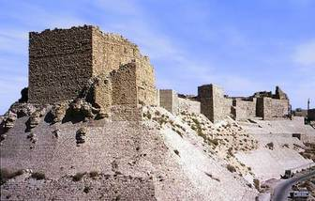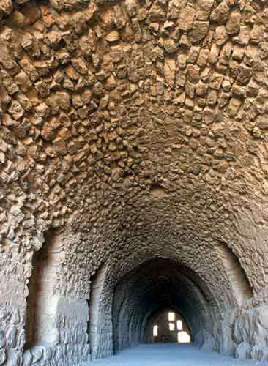

There was a stronghold of some kind here long before the crusades, it was a spot of great strategic importance, overlooking the King's Highway - a main trade route and the route of pilgrims on their way to Mecca. It was the invading Christian army that was responsible for the foundations of the structure but it was much improved by its subsequent owners, the Mamelukes, following its capture by Saladin in 1188.
Much of the castle is ruined, but parts have been restored. The Mameluke Palace and the Western Tower from which the last Christian owner of the castle used to have condemned men thrown onto the rocks below are both in a reasonable state of repair. A small museum contains artefacts from the days of the crusades as well as prehistoric artefacts discovered in the vicinity.

Jerash:
A visit to the spectacular Roman ruins of Jerash immediately transports the visitor two thousand years back in time. The city's many splendid monumental remains, still retain the atmosphere of the once thriving metropolis, famous in its own time for magnificent temples, amphitheaters, and plazas. Jerash is less than 50 kms from Amman and can be visited as a day trip.
Jerash is known for the ruins of the Greco-Roman city of Gerasa, also referred to as Antioch on the Golden River. It is sometimes misleadingly referred to as the "Pompeii of the Middle East", referring to its size, extent of excavation and level of preservation (though Jerash was never buried by a volcano).

Jerash Festival:
Visitors to Jerash in July are in for special treat, when the Jerash Festival transforms the ancient city into one of the world's liveliest -and most spectacular- cultural event.
There are folklore dances by local groups and troupes from as far afield as Spain, Lebanon and Germany. The ancient amphitheater comes to life once more, as 4,000 spectators enjoy world-class ballet, the astounding acrobatics of the Chinese gymnasts, or hysterical comedy from an Arabic satirical team. The Jerash Festival is a must-see if you're in Jordan at the time, and well worth visiting the country for specially.

Must see:
Hadrian's Arch, Hippodrome, Forum (Oval Plaza), The Cardo, Agora, Nymphaeum, Temple of Artemis, Jerash Archaeological Museum

Wadi Rum:
70km (43miles) from Aqaba is Wadi Rum - considered the world's best desert landscape. A wadi is a watercourse valley although in the case of Wadi Rum, the wadi has long since dried up.

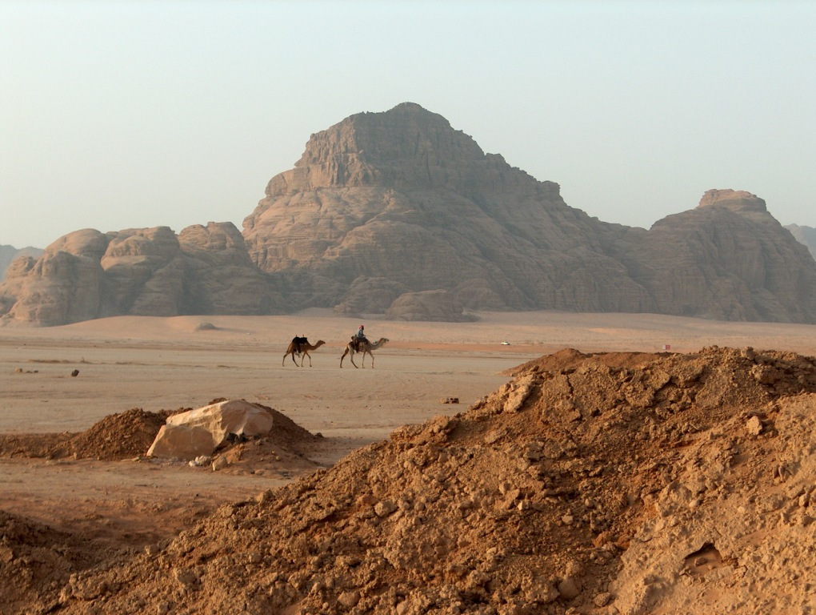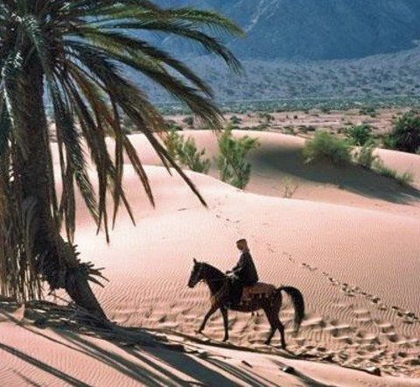

Reached by a small road off the main Desert Highway the small town of Rum is made up of the sparsely distributed tents of the nomadic people of the region, a small garrison of desert soldiers and a couple of crumbling houses. From here, you have the freedom to explore a vast expanse of desert, by either camel or 4WD. The sand here is not the normal yellow, but has a pinkish hue, which is just one reason why people make the effort to come to this part of the desert. Spectacular rock formations rise from the sand, and have made the wadi something of a target for climbers and adventure trekkers. Features such as the rock bridge of Burdah create an other-worldly landscape, particularly when the shadows lengthen as the sun falls.
The adventurous (and appropriately skilled) can try their hand at Jordan's highest peak, Jabal Rum. Travellers have been coming here for centuries and on the rocks, you can see inscriptions from various epochs in the region's history in several languages. Even if only coming here for a couple of hours make sure you time it so to experience a sunset here, as the pink sky fades into the pink grounds.
Located on Jordan's tiny southwestern coastline with the Red Sea is Aqaba, the country's only seaside city. Enjoying balmy coastal temperatures year round it is the holiday destination of choice for domestic as well as international tourists. The city itself is full of attractions, including some fabulous historic and prehistoric relics.
The discovery of what is believed to be the oldest church in the world was made in the city centre and relics such as the Aqaba Castle bear testament to the port's important role over the centuries. Here you will find the Aqaba Marine Reserve, which contains more living coral reef than both Hawaii and Bermuda. It extends over 27 sq km and features some of the world's best shallow water marine life.
It is relatively inexpensive to partake in scuba diving whether beginner or old hand. If you'd rather stay on top of the waves and let the sea life come to you there are always boats in the harbour ready to take you out for a spot of deep-sea fishing.

Aqaba and the Yamanieh Reef
Located on Jordan's tiny south-western coastline with the Red Sea is Aqaba, the country's only seaside city. Enjoying balmy coastal temperatures year round it is the holiday destination of choice for domestic as well as international tourists. The city itself is full of attractions, including some fabulous historic and prehistoric relics.
The discovery of what is believed to be the oldest church in the world was made in the city centre and relics such as the Aqaba Castle bear testament to the port's important role over the centuries. Here you will find the Aqaba Marine Reserve, which contains more living coral reef than both Hawaii and Bermuda. It extends over 27 sq km and features some of the world's best shallow water marine life.
It is relatively inexpensive to partake in scuba diving whether beginner or old hand. If you'd rather stay on top of the waves and let the sea life come to you there are always boats in the harbour ready to take you out for a spot of deep-sea fishing.

Hammamat Ma'in and Macherus
Located 35sq kms (22 miles) from Madaba the natural hot springs of Hammamat Ma'in, have for centuries been a popular spa resort with everybody from biblical royalty to modern day tourists. The large natural spa features a hot, cascading waterfall and thermal spring where you can bathe and swim in mineral rich naturally heated water. For people who want a little more there is a private resort, complete with its own springs from the same source as the public bathing area, and health facilities offering therapeutic treatments varying from mud baths to body massages.
Nearby are several sites of significance. The Palace at Macherus (Makawer) is the place where Salome danced for King Herod and received in return the head of St John the Baptist, martyred by Herod. Sitting atop a 700m-high bluff the palace occupied a formidable aspect and today offers some incredible views, on a good day spanning right across the Dead Sea into the West Bank as far as Jerusalem.

Ajloun Nature Reserve
One-and-a-half hour's drive north of Amman is the wide-open woodland of the Ajloun Nature Reserve, extending across hilly countryside covering some 13km sq. This is a fabulous place for exploration with well-marked hiking trails and secluded camping sites.
You can often spot roe deer and Persian fallow deer amidst the lush oak forest, or the pistachio, carob and pine trees that form one of the most southerly evergreen woodlands in the world. There are also significant populations of other forest wildlife, including birds and smaller mammals such as badgers and foxes. The lush scenery belies your perceptions of Jordan as a desert nation: walking under the canopy you could be anywhere in Europe.

Shopping:
There are a number of distinctive items that make unique and memorable souvenirs of a visit to Jordan. Traditional arts and crafts can now be found all over the nation. One thing that you should definitely look out for is the handmade Hebron glass, from the town of Na'ur near to Amman. Although you'll find shops in the city that sell Hebron artefacts, from glasses and tumblers to full chandeliers, you can also take a trip to the factory and see how the glassware is manufactured according to centuries old patterns.
Articles of Bedouin manufacture carry with them something of the spirit of the Middle East and you'll find plenty of items of this ilk for sale in markets wherever you travel. Woven rugs and hangings made from the wool of Bedouin sheep herds don't come cheap but are of the highest quality.
Copperware, brassware and fantastic gold and silver jewellery, in traditional Middle Eastern designs, are all excellent purchases. Prices for precious metals are often based on weight, with the addition of a standard price for the craftsmanship that has gone into the manufacture of an item.
Jordan prides itself on its handicrafts, and in recent years with the help of the Noor Al Hussein Foundation and Queen Alia Fund, has promoted local artisans. Many of those products are found in the numerous shops and markets in Amman. Silver and gold handmade items are sold at bargain prices in markets and at various shops. Silver ornaments traced to Bedouin roots are available in a variety of styles - bracelets, amulets, chokers, rings, to name a few.
Handmade glass, made from recycled bottles, is blown into vases and other vibrantly coloured ornamental products. One particular form of ceramics, Jerusalem pottery, is also popular. Crafted into plates, bowls, mugs, candlesticks, and other objects, the pieces are decorated with local images such as pomegranates, fish and grapes.
Speciality craft shops are scattered around Amman. Jordan River Designs on Abu Bakr al Siddiq Street is a local arts and crafts shop sponsored by a self-help project Save the Children. All the proceeds go to the women who produce the items. Al-Aydi, near the Inter-Continental Hotel, was established by the Jordan Craft Development Centre in the 1970s for Jordanian artists to practise their skills. This shop carries Palestinian tapestries, jewellery, antique silver, Bedouin carpets and items made from olive wood.
Aside from crafts, Dead Sea products are prevalent in pharmacies and boutiques in Amman. Products include bath salts, skin creams and other beauty aids.
Between the Al Husseini Mosque and the Citadel is Amman's famous gold souq, most notable for its variety of handmade gold and silver crafts. This is the place to bargain hard for goods. Souvenir shops are prevalent in front of Hashemite Square, between the Roman Theatre and Raghadan Station.
Amman's main shopping centres are located in Shmeisani, Sweifieh, Jebel Al Hussein, and Abdoun. Safeway, in Shmeisani, is the largest department store in Amman. The Amman Mall, near the Holiday Inn, was the first Western-style mall in Jordan and now features everything from a Nike shop to Dukan Zaman, an Islamic clothing store.
Shopping hours in Amman are flexible, usually from about 09h30-13h30 and again from 15h30-18h00. Some will open right through from 08h00-20h00. Many shops close on Fridays, but the souq stays open. Shops tend to close earlier during the month of Ramadan.

Indian Restaurants in Jordan:

Restaurant Name | Telephone | Location
Bukhara | 4641361 | Hotel Intercontinental
Indian Restaurant | 5819829 | 8th Circle
Kashmir | 4659520 | Jabal Amman
India Chicken Tikka Inn | 4642437
Indu Restaurant | Tel. 4641361 | Jabal Amman , 3rd Circle

